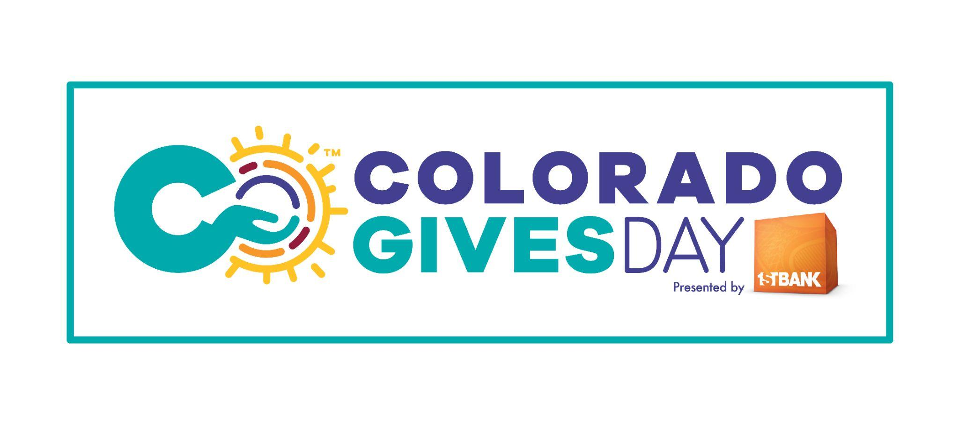

**COLORADO GIVES DAY ANNOUNCER READS**

**(:15) ANNOUNCER READ**

Imagine the amount of good we can do together.  
Colorado Gives Day is December 10th …  
and it’s easily the best day to give to the causes you care about.  
Donate now through December 10th at Colorado Gives Day dot Org.

**(:30) ANNOUNCER READ**

What if there was a day when we all came together to give to the causes we're passionate about?  
Well…there is!   
It’s Colorado Gives Day on December 10th …and it's easily the best day to give.  
At Colorado Gives Day dot org, you can…

*Option 1: d*onate to support **[insert organization or cause]**

**Or**

*Option 2:* choose from more than 3,800 nonprofits to find the causes that matter most to you.

Join the wave of generosity across the state. Give now through December 10th to **[insert organization name]** at Colorado Gives Day dot org.

**(:30) ANNOUNCER READ**

Colorado is lucky to have a special day when we all come together to celebrate and lift up our local communities.

It’s Colorado Gives Day…when we can all give to the causes we care about.

No matter how much you give, the result is the same - we get to celebrate the magnitude of good that we create together.

Give early at Colorado Gives Day dot Org to **[insert organization name]** now through December 10th. Colorado Gives Day. Easily the best day to give.